MSOT Molecular Target Detection Software – version 1
This GUI implements multispectral detection algorithms for MSOT. All algorithms implemented intend to detect the distribution of an extrinsic molecule with known absorption spectrum from the absorbing tissue background. All algorithms are described in the following two papers:
S. Tzoumas, N. Deliolanis, S. Morscher, and V. Ntziachristos, _Unmixing molecular agents
from absorbing tissue in multispectral optoacoustic tomography Medical Imaging, IEEE
Transactions on, vol. 33, no. 1, pp. 48_60, 2014.
S. Tzoumas, A. Kravtsiv, Y. Gao, A. Buehler, V. Ntziachristos, "Statistical molecular target
detection framework for multispectral optoacoustic tomography," Medical
Imaging, IEEE Transactions, Accepted

- Algorithms:
OSP: Orthogonal Subspace Projection is equivalent to Linear Unmixing. It performs a linear regression using the spectra of oxygenated and deoxygenated hemoglobin for the tissue background and the spectrum of the target agent.
OSP is also described in:
S. Tzoumas, N. Deliolanis, S. Morscher, and V. Ntziachristos, _Unmixing molecular agents
from absorbing tissue in multispectral optoacoustic tomography Medical Imaging, IEEE
Transactions on, vol. 33, no. 1, pp. 48_60, 2014.

AMF: Adaptive matched filter is a statistical sub-pixel detection algorithm originally used by the Radar community and hyperspectral imaging community. It models the background statistically as a multivariate Gaussian distribution based on the available data. It has been found to statistically outperform linear unmixing when the targets are sparse within the image. The performance of AMF degrades when the target is in high amount within the data.
Original publication of AMF:
F. C. Robey, D. R. Fuhrmann, E. J. Kelly, and R. Nitzberg, _A CFAR adaptive matched
filter detector, Aerospace and Electronic Systems, IEEE Transactions on, vol. 28, no. 1,
pp. 208_216, 1992.
First use in the context of MSOT:
S. Tzoumas, N. Deliolanis, S. Morscher, and V. Ntziachristos, _Unmixing molecular agents
from absorbing tissue in multispectral optoacoustic tomography Medical Imaging, IEEE
Transactions on, vol. 33, no. 1, pp. 48_60, 2014.

AMF QL shr.: This is an adapted version of AMF developed specifically for MSOT data. It uses an archive of training MSOT data to better model the tissue background. This allows AMF QL shr. to operate well even when the molecular target is in high amount within tissue, where AMF fails. It has been found to perform slightly worse than AMF when the target is in low amount.
AMF QL shr is described in
S. Tzoumas, A. Kravtsiv, Y. Gao, A. Buehler, V. Ntziachristos, "Statistical molecular target
detection framework for multispectral optoacoustic tomography," Medical
Imaging, IEEE Transactions, Accepted

RSDF: This is another adapted version of AMF developed specifically for MSOT data. It uses an archive of training MSOT data to better model the tissue background. This allows RSDF to operate well even when the molecular target is in high amount within tissue, where AMF fails. Furthermore it models the background data using a t-distribution instead of a Gaussian. It has been found to perform better than AMF QL shr. in the case of low intensity targets.
RSDF is described in
S. Tzoumas, A. Kravtsiv, Y. Gao, A. Buehler, V. Ntziachristos, "Statistical molecular target
detection framework for multispectral optoacoustic tomography," Medical
Imaging, IEEE Transactions, Accepted

- Thresholds:
For the case of AMF and AMF QL Shr. three thresholds are available that intend to assist in the interpretation of the data. AMF has a Constant False Alarm Rate (CFAR) property which allows to define a global detection threshold that is associated with a specific probability of false alarm. The three thresholds are derived from a database of MSOT data that contain no extrinsic absorbing molecules (only background). Based on this database, three thresholds associated with a specific Probability of False Alarm (PFA) are derived. Based on this PFA, the number of false positive pixels expected per image is also displayed (i.e. 100, 20, 5 pix). The last threshold is typically associated with a very small false alarm rate.
Information on these thresholds has not been published and this is more for internal understanding.
- Target spectrum
The target spectrum can be loaded either from a preselected set of spectra or from an .xls file. The .xls file should contain only two column, the first containing the wavelengths and the second the absorption intensity. The target spectrum is always displayed in the left bottom figure.

- Loading the data
The GUI is compatible with i-Thera data representation and it can load data that have been reconstructed with the MSOT X-View software. The data should be already reconstructed within the folder RECONs.
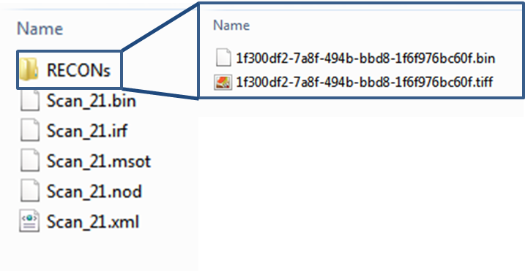

.mat files with the data can also be loaded. In this case the .mat file should contain the reconstructions in a variable the name of which starts with ‘Recon’. The images should be in one of the following formats:
[x, y, wavelengths]
[x, y, slices, wavelengths]
[x, y, runs, slices, wavelengths].
The struct “datainfo” should also be present in the .mat file.
- Inspecting the spectra
By clicking on the preview image the spectrum at the location of the cursor is displayed in the bottom right. By clicking the ‘Select ROI’ button the user can select a region of interest in the figure that appears and the mean spectrum from this region of interest is displayed in the bottom right. By clicking Export Spectrum the spectrum shown in the preview is saved in an XLS file at a specified location.
- Exporting the unmixing results.
By clicking the ‘Export’ button and selecting a folder another folder with the name of the dataset is automatically created. Within this folder three subfolders containing the anatomical images, the unmixed component and the overlays (all in .tif format) are automatically saved. Each image is named according to the dataset and the run/slice that it corresponds to. The name of the images also contains the algorithm that was used to analyze the data, the threshold index (1-4) and the visualization saved.

For more information and for reporting Bugs or weird cases please contact strtzoumas@gmail.com

